**HOMEWORK 6**

1. For the following functions simplify using K-Map



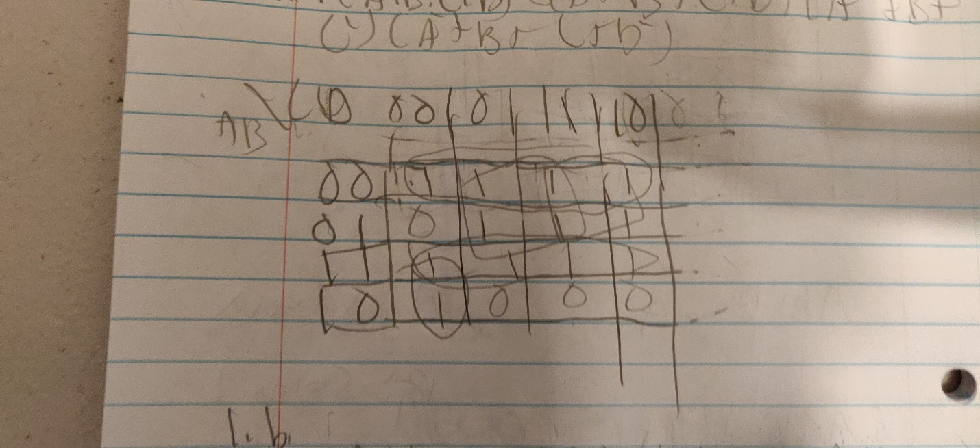

AC’D’



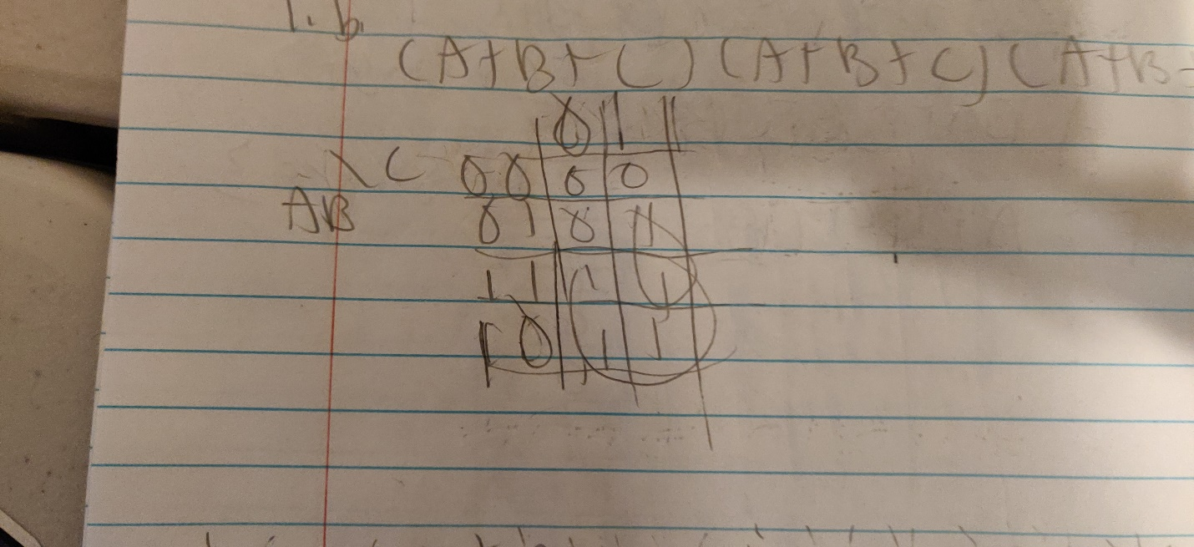

BC+A



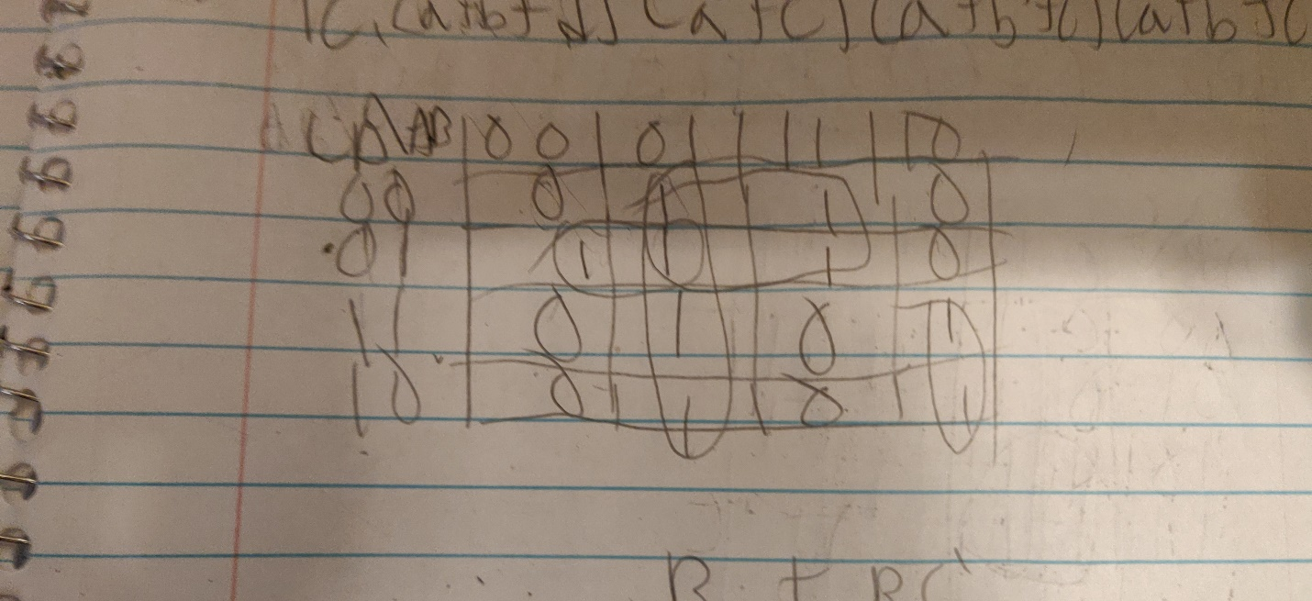

B+BC’



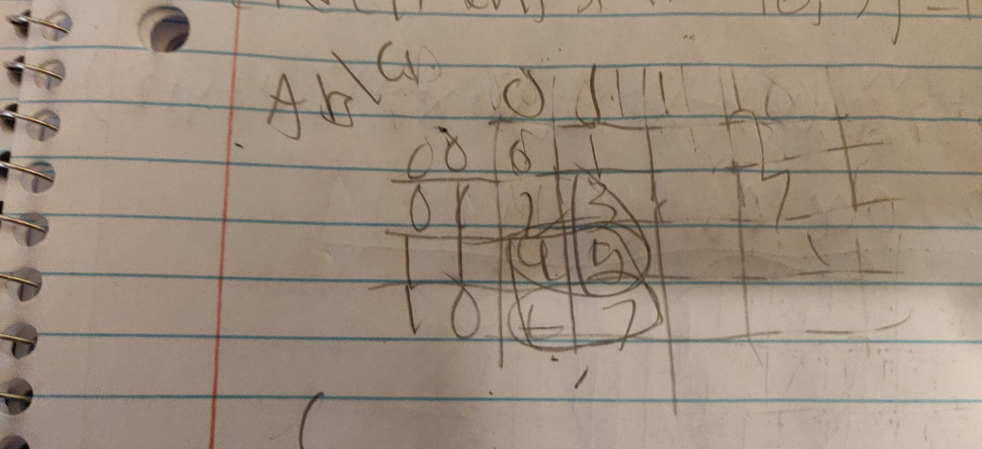

C





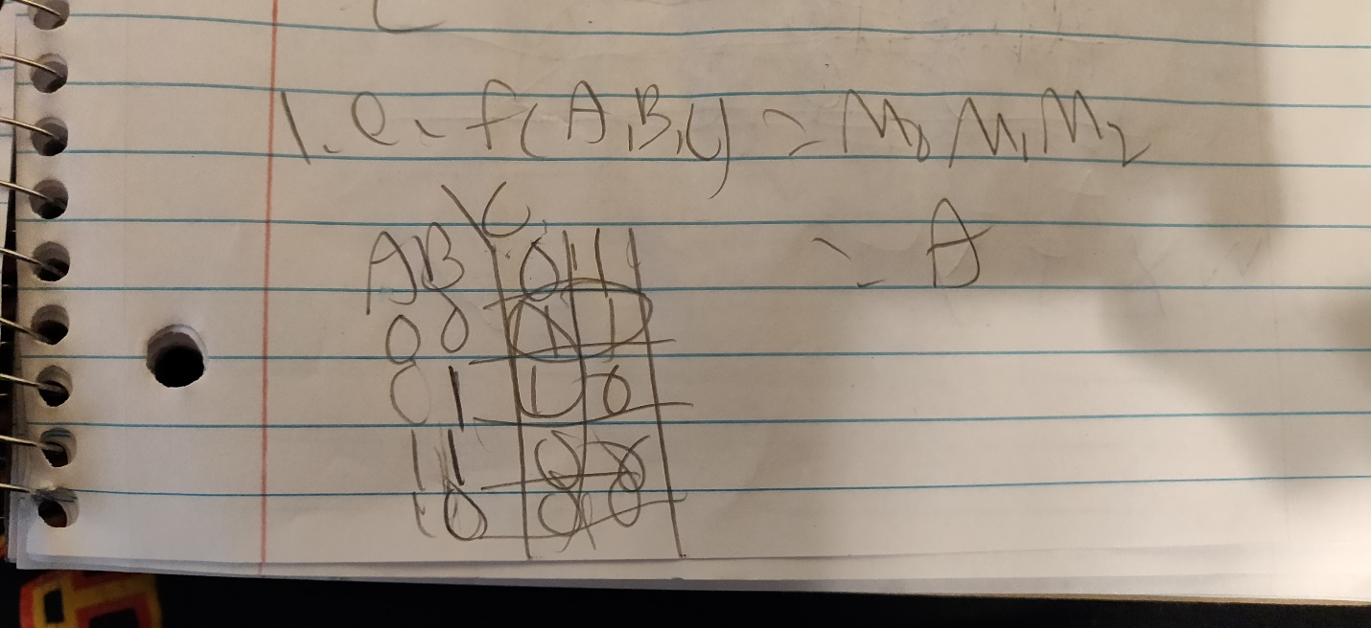

A+C



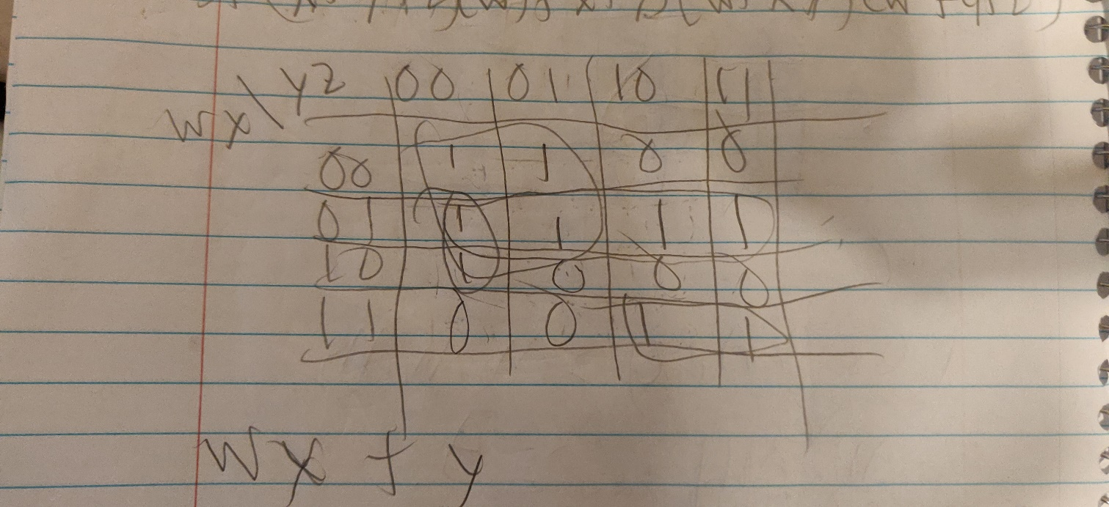

WX+Y

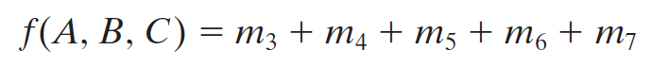

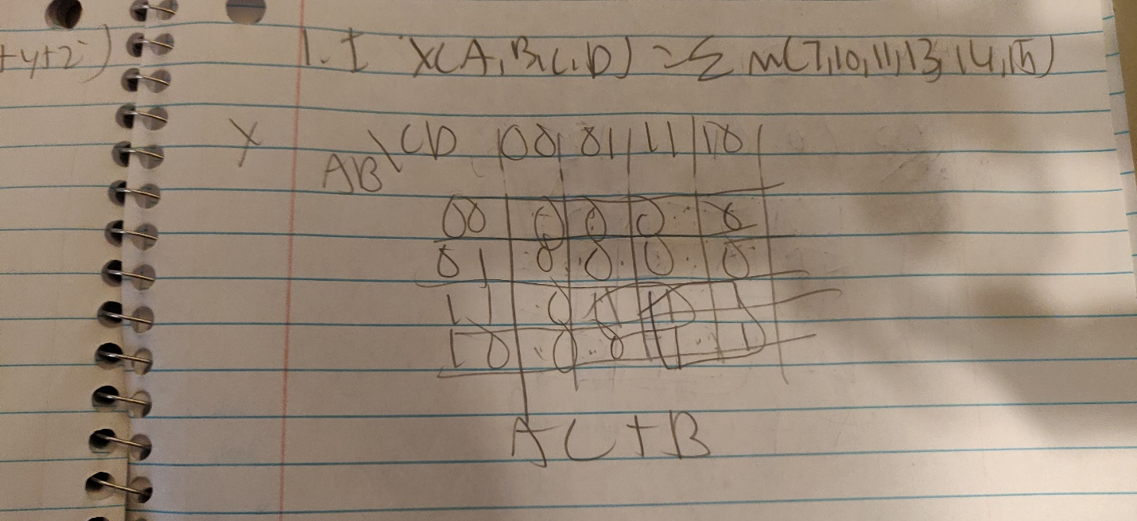

AB+C

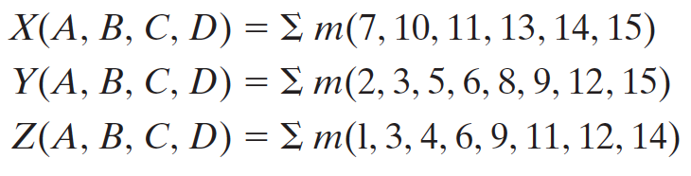



X=AC+B

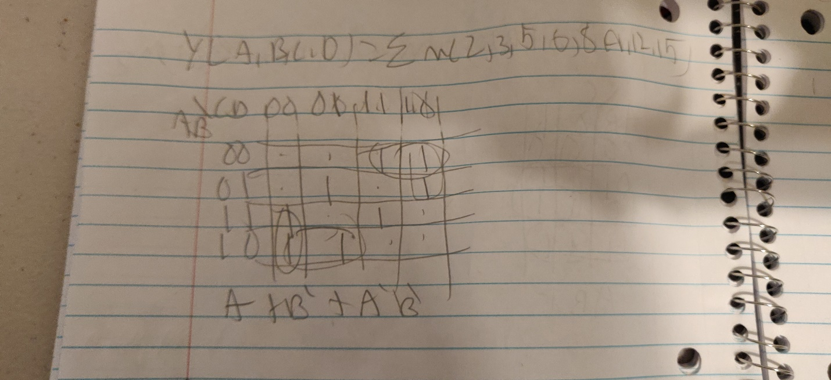

Y=A+B’+A’B’

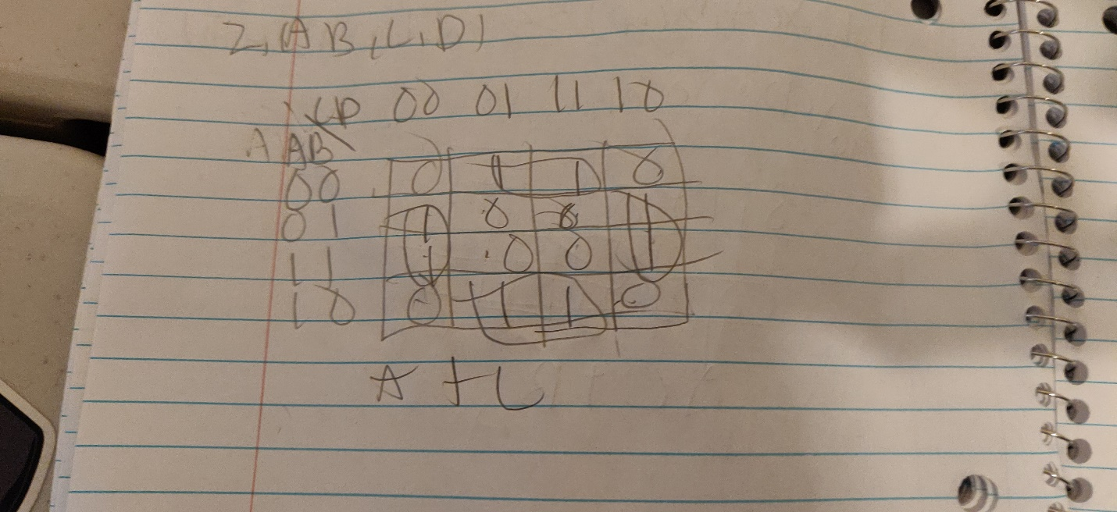

Z=A+C

**2)** Derive the Boolean function in a POS form from the following truth table



Draw the circuit in Logisim and test the truth table

Simplify the function using KMap.

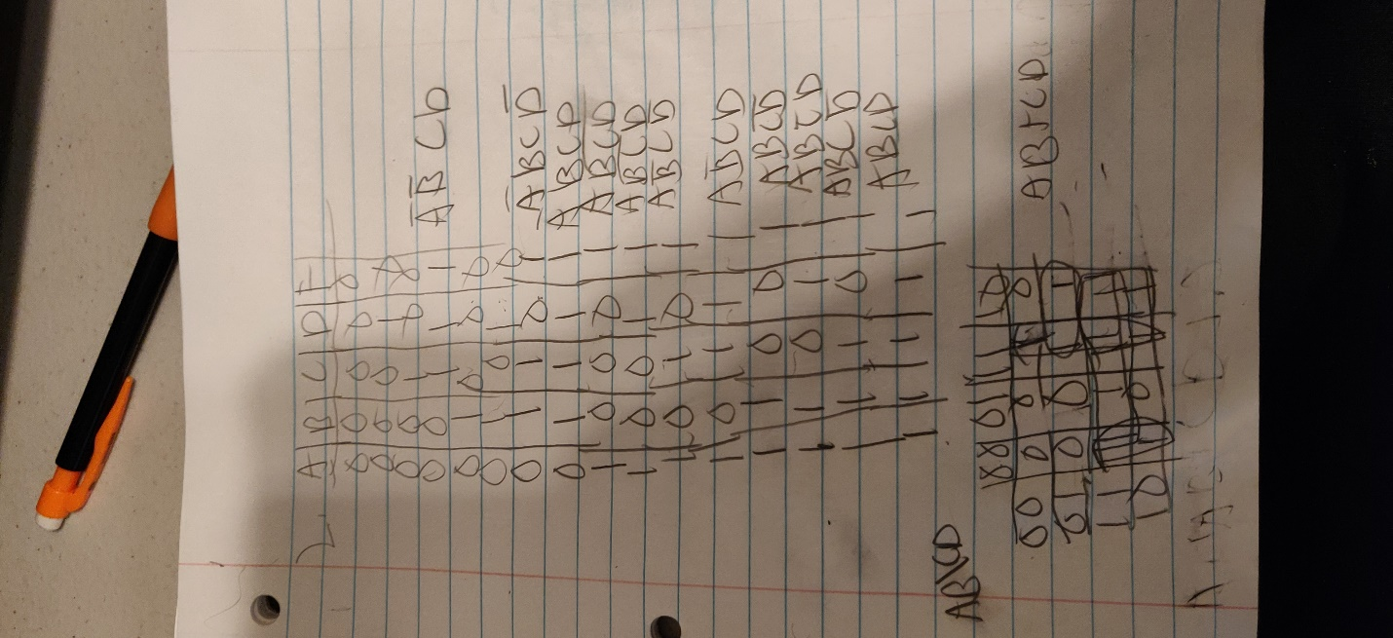

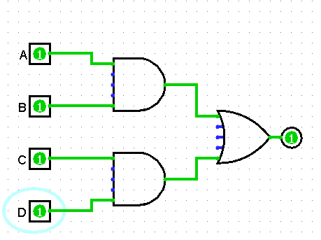

AB+D+A

Design an equivalent circuit only using NOR gates and test the truth table using Logisim.

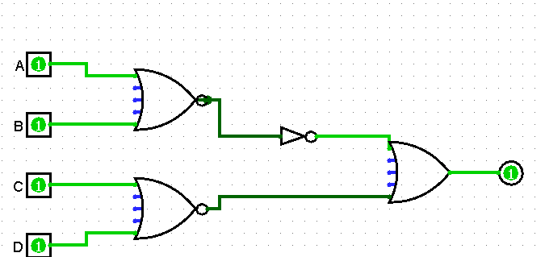

**3)** From the following truth table derive the Boolean Expression in a POS from, simplify using K-Map and draw the Logic Diagram that represent the simplified circuit.

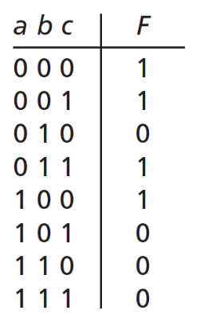

B+A’B’

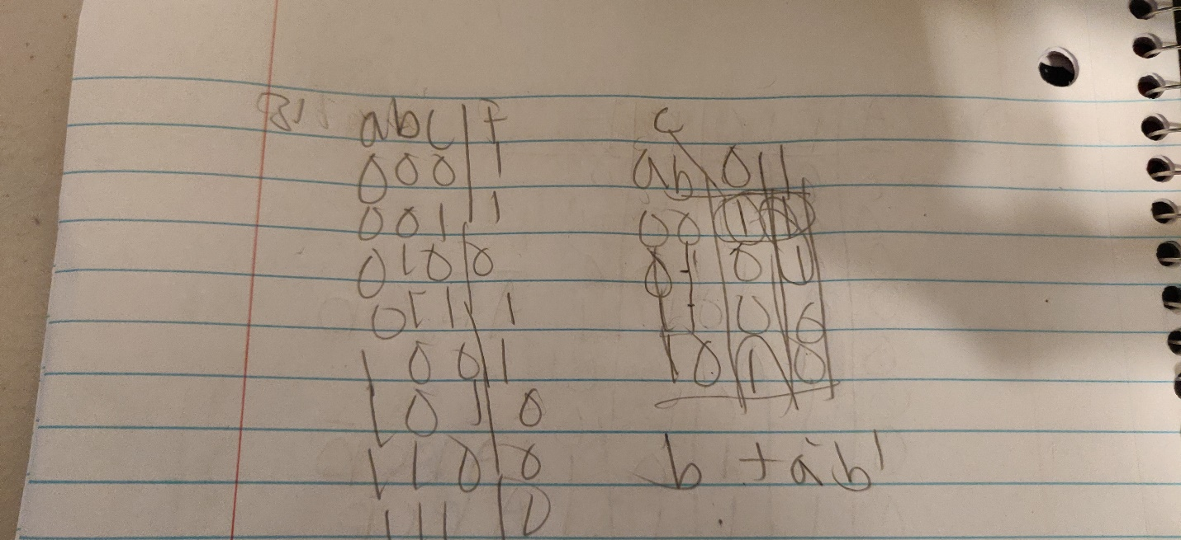

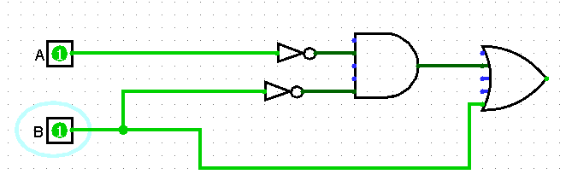

**4)** From the following truth table derive the Boolean Expression in a POS from, simplify using K-Map and draw the Logic Diagram that represent the simplified circuit.

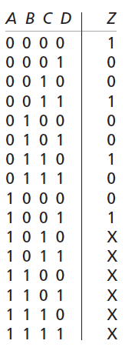

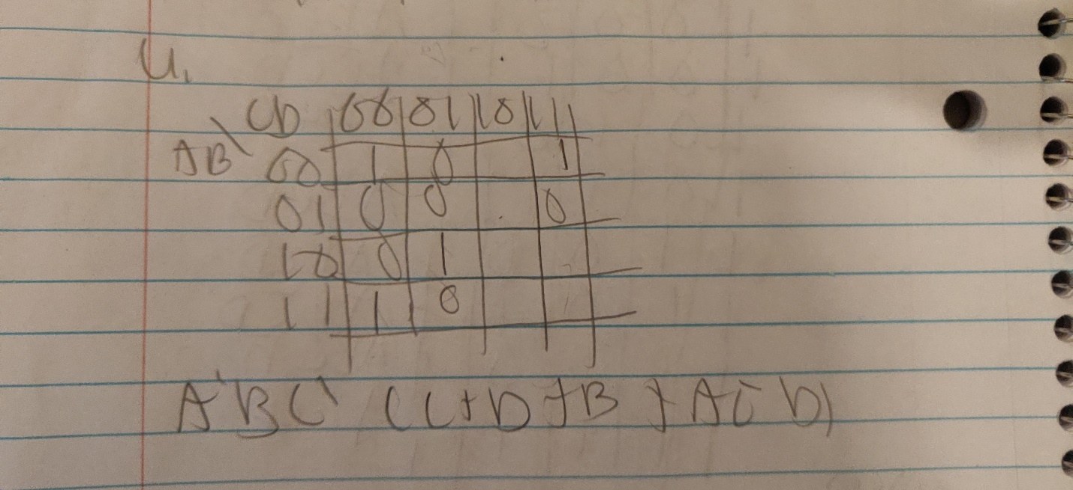

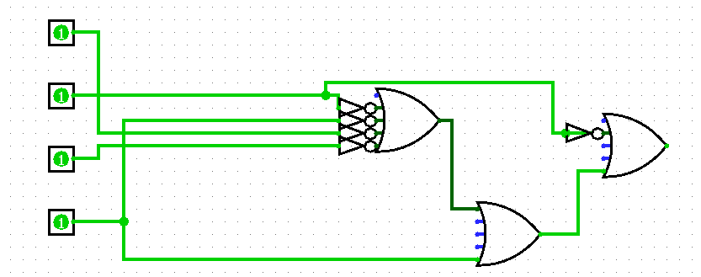

**5)** From the following K-Map derive the simplified Boolean Expression in a SOP and in a POS form. Draw both Logic Diagram that represent the circuits.

